**Article 1:**

Vaughan, N. & Gabrys, B. (2016). Comparing and combining time series trajectories using Dynamic Time Warping. *Procedia Computer Science, 96,* 465 – 474. doi:10.1016/j.procs.2016.08.106

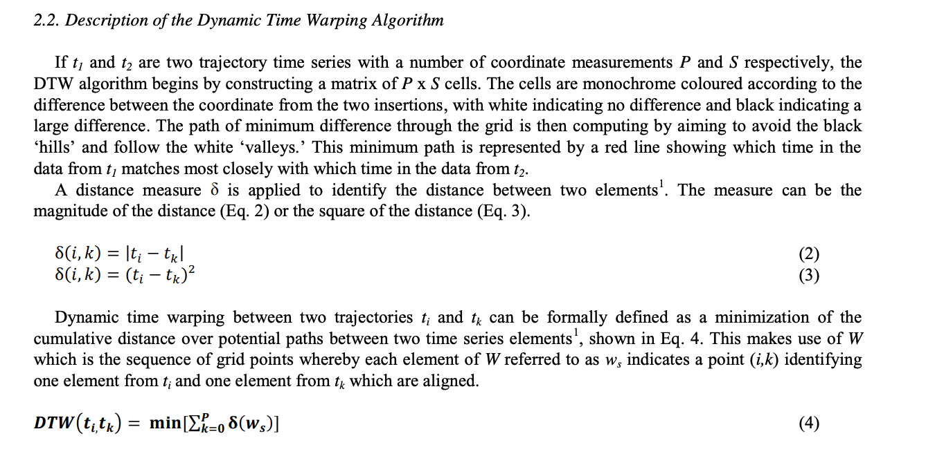

**Notes:**

* This article describes the Dynamic Time Warping algorithm, one of the most popular algorithms to compare trajectory data
* The algorithm can be used to compare two different trajectories of time series data (meaning data that has a spatial and temporal depth).
* Dynamic Time Warping algorithms return similarity metrics between two trajectories, allowing for more advanced comparison than simple Euclidian distance comparison.

**Significance:**

* I can use this algorithm as a similarity metric to compare my data, since my trajectories consist of points of “temperature centers” with a spatial depth (x and y within the disc) and a temporal depth.
* I can also use the similarity metric from the Dynamic Time Warping in the optimization process as the measurement function that gives me the “loss” of my optimization, or the value that will be measured while minimizing the print parameter variables.

**Article 2:**

Studer, M & Ehrig, F. (2014). Minimizing part warpage in injection molding by optimizing wall thickness distribution. *Advances in Polymer Technology, 33*. doi:10.1002/adv.21454

**Notes:**

* This paper is about part warpage in injection molding, which is similar to 3D printing in the thermoelastic properties.
* The researchers optimized wall thickness distributions using three derivative-free optimization algorithms, and found that the genetic algorithm’s wall thickness distribution output was the best to reduce warpage.
* They are also the only modern paper about wall thickness and warpage/thermodynamics in 3D printing.

**Significance:**

* I can use a genetic algorithm or a surrogate-based optimization approach for my four process variables.
* Since wall thickness has been studied before and has been found to reduce warpage when optimized in this study, I know it is an important process variable in my project.

**Article 3:**

Zhang, J., Wang, X. Z., Yu, W. W., Deng, Y. H. (2017). Numerical investigation of the influence of process conditions on the temperature variation in fused deposition modeling. *Materials & Design, 130,* 59-68. doi:10.1016/j.matdes.2017.05.040

**Notes:**

* This article built a mathematical model to visualize and understand the effect of multiple variables on temperature variation.
* They studied layer thickness, printing speed, temperatures of extruder/build plate, and geometry dimensions on the temperature variation throughout the component.
* However, they assumed that infill has no effect and warpage is negligible.

**Significance:**

* This article gives me an understanding of what each individual variable has on the overall temperature variation.
* It also has a couple of mathematical models for the different relationships between the variables